**Proposal Summary**

In this project, we propose to utilize the ground-based microgravity analog of Hindlimb Unloading (HU) in mice to determine the sex-specific risks of single and combined effects of long-term, low-dose irradiation and stress-induced social isolation on the central nervous system (CNS), immune system and behavioral/cognitive impairments. We describe an integrative approach linking neuroimmune homeostasis to brain morphological changes, oxidative stress, circadian rhythms, behavior and cognition in wild-type (*Wt*) and mitochondrial catalase transgenic mice (*mCAT*) exposed to a longitudinal continuum of low-dose irradiation and HU (pre-exposure baseline, days 2, 7, 14, 30 during exposure, and 14 days post-exposure). Antioxidant () dietary countermeasure efficacy in *Wt* mice exposed to similar conditions. The proposed project relies on established and highly translatable models will generate research results on biomarkers, performance pathways, and functional impairments that can be extrapolated to estimate risks to humans exposed to the space radiation environment while concurrently experiencing the stress of isolation and confinement, and physiological adaptations due to altered gravity. The research results are aimed to assess the time-course for exposure to, and recovery from, oxidative stress induced by combined irradiation and microgravity exposure on the central nervous and immune systems of mice, immunity in mCAT mice, and potential reversal using a dietary countermeasure, with the overall goal to minimize these associated risks in both male and female astronauts on long-term, deep space missions. The project is closely aligned with NASA-HRPs goal of a deeper understanding of irradiation and microgravity, and its potential application to develop effective countermeasures to mitigate negative health effects of long duration space habitation.

**Oxidative stress and the neuroconsequences of the spaceflight environment –**

**Immune dysregulation and antioxidant dietary countermeasure efficacy**

1. **TABLE OF CONTENTS**

SECTION Page (to be updated later)

1. Table of Contents 1

2. Analog Study Resource Worksheet 2

3. Software Sharing Plan 2

4. Map to Human Research Roadmap 2

5. Animal Care Certifications 2

6. Response to prior review 2

7. Productivity of currently funded research 2

8. Vertebrate Animal Scientific Review 3

9. Scientific and Technical Project Description 5

10. References and Citations 19

11. Management Approach 26

12. Personnel Biosketches 27

13. Current and Pending Support 36

14. Facilities and Equipment 37

15. Budget Justification of Proposed Costs 40

16. Letters of Collaboration or Support 42

17. Appendices or Reprints 45

1. **ANALOG STUDY RESOURCE WORKSHEET**

?

**3. SOFTWARE SHARING PLAN**

Not Applicable

1. **MAP TO HUMAN RESEARCH ROADMAP**

**NASA HRP risks addressed in this proposal:**

**(1)** Risk of Acute (in-flight) and Late Central Nervous System Effects from Radiation

**(2)** Risk of Adverse Health Event Due to Altered Immune Response.

**NASA HRP Gaps addressed in this proposal:**

**(1) CNS2:** Does space radiation exposure elicit key events in adverse outcome pathways associated with neurological diseases? What are the key events or hallmarks, their time sequence and their associated biomarkers (in-flight or post- flight)?

**(2) CNS5:** How can new knowledge and data from molecular, cellular, tissue and animal models of acute CNS adverse changes or clinical human data, including altered motor and cognitive function and behavioral changes be used to estimate acute CNS risks to astronauts from GCR and SPE

**(3) CBS-CN-4:** What are the most effective medical or dietary countermeasures to mitigate CNS risks? By what mechanisms are the countermeasures likely to work?

**(4) IM8:** We do not know the influence, direct, or synergistic, on the immune system of other physiological changes associated with spaceflight

**5. ANIMAL CARE CERTIFICATIONS**

IACUC Approval Pending

**6. RESPONSE TO PRIOR REVIEW**

Not Applicable

**7. PRODUCTIVITY OF CURRENTLY FUNDED RESEARCH**

Not Applicable

**8. VERTEBRATE ANIMAL SCIENTIFIC REVIEW**

**9. Scientific and Technical Project Description (15 pages)**

1. **Objectives and Significance**

In this project, we propose to determine in mice sex-specific effects of single and combined effects of long-term, low-dose irradiation and simulated microgravity utilizing ground-based Hindlimb Unloading (HU) on the central nervous system (CNS), immune system and behavior. The proposed research is an extension of our past work (see **Preliminary Studies**) and is aligned with the goals set forth in the **NASA Human Exploration Research Opportunities (HERO) 80JSC018N0001-FLAGSHIP Call for Proposals, Appendix A: NASA Research and Technology Development to Support Crew Health and Performance in Space Exploration Missions**, **Topic 1: Risk of Synergistic Effects of Radiation, Stress, and Altered Gravity on Spaceflight Behavioral Health and Performance Virtual NASA Specialized Center of Research (VNSCOR).** The fundamental questions addressed in this project examining sex differences in mouse response to space factors are: 1) Does low-dose ionizing radiation singly and in combination with simulated microgravity cause elevations in ROS and altered neural morphology in brain systems related to cognition and behavior?, and is there the interactive or synergistic role of isolation stress, 2) Do the observed CNS alterations lead to behavioral and cognitive impairments, and how do these relate to brain performance pathways?, 3) Can dysregulated immune signaling yield identification of specific biomarkers for neural and behavioral alterations?, 4) Are these responses sexually dimorphic?, 5) Are mitochondria catalase (mCAT) mice protected from CNS, immune and functional effects of space environment factors?, and 6) Can nicotinamide mononucleotide (NMN) ameliorate these changes in *wt* mice?

Here we describe an integrative approach linking neuroimmune homeostasis to brain morphological changes, oxidative stress, circadian rhythms, behavior and cognition in wild-type (*Wt*) male and female mice exposed to a longitudinal continuum of low-dose irradiation and HU (pre-exposure baseline, days 2, 7, 14, 30 during exposure, and 14 days post-exposure). These studies will also evaluate the effects of social isolation, a major risk factor for stress during spaceflight. In the second specific aim, we will analyze responses of male and female mitochondrial catalase transgenic (*mCAT*) mice to ascertain whether one or both sexes are protected from ROS, and the third specific aim will test NMN antioxidant dietary countermeasure efficacy in *Wt* male and female mice exposed to that same conditions. The proposed study will provide an excellent opportunity to assess longitudinal effects of oxidative stress induced by combined irradiation and microgravity exposure on the central nervous and immune systems of mice, and potential reversal using a dietary countermeasure, with the overall goal to minimize these associated risks in both male and female astronauts on long-term, deep space missions. Further, the proposed project relies on established and highly translatable models that will generate research results on biomarkers, performance pathways, and functional impairments that can be extrapolated to estimate risks to humans exposed to the space radiation environment while concurrently experiencing the stress of isolation and confinement, and physiological adaptations due to altered gravity. Overall, the project is well-positioned to be joined with other proposals to achieve a deeper understanding of space radiation, microgravity, and isolation on crew health during extended missions beyond Low Earth Orbit (LEO).

1. **Hypotheses and Specific Aims**

Our primary aim is to determine sex-specific, longitudinal effects of oxidative stress induced by single and/or combined irradiation and microgravity exposure, considering the role of isolation, on the central nervous and immune systems of mice, to identify underlying mechanisms and to develop effective methods for mitigating adverse health effects in astronauts on extended deep space missions. The combined (possibly) longitudinal CNS effects of irradiation, microgravity and isolation during spaceflight are not well characterized. Spaceflight models have revealed the detrimental involvement of the oxidative stress response. Our ***central hypothesis*** is that exposure to radiation, singly and in combination with microgravity, triggers the oxidative stress response, leading to impairments in behavior, cognition, circadian rhythm, neurobiology and neuroimmune homeostasis. In Specific Aim 1, we hypothesize a more pronounced oxidative stress response and structural/functional impairments in male as compared to female mice. In Specific Aim 2, we hypothesize that these changes will be ameliorated by overexpression of mitochondrial catalase. In Specific Aim 3, we hypothesize that these changes will be mitigated via feeding an antioxidant nicotinamide mononucleotide (NMN)-enriched diet.

**Specific Aim 1: To determine a longitudinal time course of brain oxidative stress and damage (OSaD), immune homeostasis and behavioral/cognitive function in male and female wild-type (*Wt*) after low dose ionizing radiation and/or simulated microgravity exposure.** We will test the hypothesis that long duration exposure to either microgravity, radiation, social isolation singly and/or in combination will result in significant oxidative stress and Damage aD within the brain and induce inflammation driven-immune dysfunction in *Wt* mice, while these effects will be mitigated in mice overexpressing the human antioxidant enzyme, catalase, targeted to the mitochondria (*mCAT*).

Recent data (see **Preliminary Studies**) indicate that social isolation is a significant stressor, affecting both behavior and neuro-immune homeostasis [1]. We observed in female mice changes in hippocampal-specific behavior and differential immune profiling based on single or paired housing conditions, indicating the importance of evaluating stress-induced social isolation effects. Therefore, we plan to conduct all proposed experiments in both social and single housed HU, comparing responses of male and female mice. This will enable an expanded understanding of the underlying physiological mechanisms of social isolation induced-stress, which is extremely relevant to isolation and confinement that will be experienced by astronauts during long term, deep space travel. This integrative project incorporates the following approaches:

**1A:** Assess neuronal and glial impacts due to radiation and/or microgravity. Preliminary studies in our lab indicate upregulation of oxidative stress response genes in the nervous system of Drosophila melanogaster (fruit flies) and increased ROS levels in the brains of flies subjected to ground-based chronic and acute hypergravity (3g) exposure. It is known that different regions of the brain are differentially vulnerable to oxidative stress in brain [2]. In this aim we plan to measure oxidative stress response-dependent markers different areas of brain that are involved in cognitive function and memory (cortex, midbrain and hippocampus). Furthermore, we plan to assess synaptic integrity and density in the hippocampus region. Preliminary studies in flies exposed to chronic hypergravity (3g) show that in addition to increased ROS production, there is a significant decrease in DA neuron counts in adult brains as compared to 1g controls. In lines with this finding, we will look at dopaminergic (DA) neuron count, as oxidative stress can lead to loss of DA neurons [3]. Furthermore, we plan to assess microglia and astrocytic activation due to HU +/- irradiation by quantifying cell specific protein expression using established methods [4]. We also aim to identify the various processes and pathways involved in altering neuro-anatomy, neurodevelopment, neurophysiology and behavior. Here, we propose to perform transcriptomic analysis on mouse brains, using RNAseq and qRT-PCR to examine the alterations in the transcriptional profiles in the nervous system in wild type and the antioxidant catalase expressing mice.

**1B:** Assess immunological impacts due to radiation and/or microgravity in CNS and peripheral blood. Preliminary studies in our lab indicate increased ROS and granulopoiesis in ground-based microgravity simulations in high-aspect rotating wall vessels (HARV-RWV), while increased granulocyte production is observed in 30-day hindlimb unloaded mice compared to normal controls. In addition, previous studies have indicated similar increased granulocyte production during space flight [5], collectively suggesting dysregulated immunity and a prominent oxidative stress profile during spaceflight. However, the combined effects of irradiation exposure and microgravity conditions on the health of the immune system, and its impacts on the CNS has not yet been thoroughly studied. There is a strong implication for immune system contribution in CNS health and disease [6, 7]. Importantly, the timing of immune cell infiltration/efflux into and out of the CNS following stimuli, and the contribution of this to the integrity of the BBB, is an important event that is only marginally studied in the field of irradiation and microgravity. Specific aim 1 will determine the immune population shifts, cytokine profiles and hormonal balance in peripheral blood circulation and within the CNS following low-dose irradiation and microgravity exposure of *Wt* mice at multiple time points. Immune profiling would include a panel of markers to label: leukocytes, T helper lymphocyte, T cytotoxic lymphocytes, monocytes, neutrophils, B cells, and natural killer cells, while cytokine levels of known BBB integrity inflammatory mediators will be analyzed. These longitudinal timepoints would successfully determine the predominant immune profiles observed within the CNS and in peripheral blood circulation following single and combined microgravity and low-dose irradiation. **BIOMARKER APPROACH**

**1C:** Assess physiological alterations and behavioral changes in species-typical behaviors associated with single and combined effects of the three spaceflight factors. Physiological data acquired from wireless telemetric sensors (TSE Stellar) will provide activity, temperature and electrocardiographic signals in both *singly- and group-housed* male and female mice. Physiological data will be used to assess adaptation to and recovery from HLU, radiation and social isolation manipulations, and correlated with in-cage behavioral and pre-post exposure cognitive and emotionality tests results. Sensors will be surgically implanted two weeks prior to the start of the experiment in mice exposed space factors for 30 days followed by 14 days recovery behavioral monitoring will be conducted continuously over the course of the experiment in order to accelerate characterization of any subtle or gross behavioral deficits associated with HU and/or irradiation in real-time: (1) Vocalization, recordings of mouse vocalizations and frequency modulations during all behavioral tests, data points collected during periods of light and dark cycles, and; (2) Continuous observational video, to document conspecific and maladaptive behaviors due to treatment exposure, feeding and drinking pattern, social and single housing, circadian rhythm, and overall activity.

**1D:** Assess behavioral and cognitive deficiencies using home-cage and pre-post exposure testing. Most murine behavioral tests conducted in the context of microgravity and/or irradiation are done post-exposure, i.e. monitoring acclimatization changes. We will utilize a battery of behavioral tests to identify effects of microgravity, radiation and social isolation. This approach will facilitate assessment of the timing of behavioral changes in relation to simulated space environmental exposure that can be better used to define the stage of neuropathology. Accordingly, behavioral assays that will assess functional changes in brain regions involved in learning/memory and decision making, prefrontal cortex and hippocampus, will include: (1) Object Recognition/Novel Object Recognition (NOR), a test for recognition and memory; (2) Y-maze, will assess spatial learning and cognition; (3) The Three-Chamber test, assess sociability and social memory; (4) Morris Water Maze to assess working memory. Further, we will employ behavioral assays that will assess emotional dysregulation: (1) Splash test, assesses anxiety/depression-like effects in mice; (2) Elevated Plus Maze to assess anxiety. All behavioral tests will be modified and adapted to be used with the HU rodent model, that has been established by Dr. Ruth Globus, a Co-I on this proposal with the behavioral analysis for that effort led by the Ronca Laboratory. We anticipate that these assays will provide a sensitive assessment of cognitive and emotional disruption, and therefore define alterations of functional output over time during exposure to the simulated space environment. ***This approach is novel in its attempt to quantify and define early and late stage cognitive/behavioral pathology in relationship to predictable neurological damage and provide discrete space specific risk assessments.***

**Specific Aim 2: To determine a longitudinal time course of brain oxidative stress and damage (OSaD), immune homeostasis, physiological status and behavioral/cognitive function in male and female catalase transgenic (*mCAT*) mice after low dose ionizing radiation and/or simulated microgravity exposure, and social isolation.**

Mitochondria dysfunction induced by reactive oxygen species (ROS) is common to numerous human diseases and aging. In physiological conditions, the mitochondrial respiratory chain is the major source of ROS. ROS has been shown to be reduced by intracellular antioxidant enzymes including superoxide dismutase, glutathione peroxidase and catalase. Recent work from the Globus Laboratory, in collaboration with the Bhattacharya Laboratory see **Preliminary studies**) have revealed that mCAT mice are protected from altered immune homeostasis in response to HLU, and further effects of social versus single (isolation) housing. ***In this aim, we hypothesize protection of mCAT mice from ROS production, neuroimmune and behavioral-deficits associated with simulated microgravity and/or irradiation, and social isolation. Precise tests and timepoints will be selected based upon the results of SA1.***

**Specific Aim 3: To mitigate microgravity and/or irradiation associated deficits in mice via oral administration of Nicotinamide Mononucleotide (NMN).** NMN is a key intermediate in nicotinamide adenine dinucleotide (NAD+) biosynthesis. NMN is adenylated to NAD by nicotinamide mononucleotide adenylyl transferase (NMNAT) thereby contributing to the NAD+ pool. NAD+ is a cofactor required for cellular metabolism, mitochondrial ATP production, maintenance of redox potential and DNA repair [8]. Moreover, depletion of NAD+ pool is associated with various disorders such as cancer [9], metabolic disorders, nervous system disorders [10], as well as, in aging [11]. NAD+ consuming enzymes such as, poly-ADP-ribose polymerases (PARP) and Sirtuins (SIRTs), play a pivotal role in DNA repair, resistance to oxidative stress and circadian rhythm [12]. In vitro studies of exogenous supplementation of NAD+ have shown this compound to be protective against death induced by oxidative stress in neurons [13, 14] and cardiac myoblasts [15]. Similarly, subcutaneous NMN injection ameliorated NAD+ catabolism and mitochondrial dynamics deficits associated in AD mice model [16]. Previous work has shown that oral administration of NMN at a dose of 300 mg/kg/day through drinking water helps alleviate aging symptoms by increasing the NAD+ pool in various tissues [11]. ***In this aim, we hypothesize that oral administration of NMN would help mitigate microgravity and/or irradiation associated neuroimmune and behavioral-deficits observed in Aims 1 and 2, thereby assessing NMN as a potential dietary countermeasure for future spaceflight missions in astronauts. Precise tests and timepoints will be selected based upon the results of SA1.***

1. **Background (~2.5-3 pages)**

Exposure to radiation and microgravity conditions are two major risks that will be encountered by astronauts during deep space missions. A better understanding of how both radiation and microgravity combined, in addition to multiple other spaceflight factors including, confined living space, sterile environment, and fluctuating circadian rhythms, can influence human physiology is required to mitigate potential health risks predicted to occur during deep space exploration and long-term space habitation. Exposure to microgravity and ionizing radiation have been well-documented to generate multiple physiological risks including, immune dysfunction [17]and neurological/cognitive deficits [18]. The mechanisms underlying the neuroimmune effects of combined, long-term exposure of these principle spaceflight-induced stressors remain elusive. Further, there is a major need to identify ensuing behavioral/cognitive changes, their associated performance pathways, and predictive biomarkers. Additionally, the development of countermeasures targeting neuroimmune and behavioral/cognitive health risks is lacking, however ***appropriate countermeasures are vital to crew health and safety during extended duration, deep space exploration missions currently being planned by the agency.***

*Mouse Models and Spaceflight Analog Approaches.*

*MCAT mouse model*

Transgenic mCAT mice over-express the human catalase gene targeted to mitochondria. Catalase is an anti-oxidant that converts reactive species, hydrogen peroxide (H202), into water and oxygen. This animal model displays extended lifespan {Schriner, 2005 #90} and reductions in numerous pathologies {Treuting, 2008 #91;Mao, 2012 #85;Dai, 2010 #80} including cardiovascular disease {Dai, 2009 #89;Dai, 2010 #80;Dai, 2011 #83;Dai, 2009, Alzheimer-related amyloid deposition {Mao, 2012 #85}, radiosensitivity of neurogenesis {Liao, 2013 #92;Olsen, 2013 #102}, all consistent with elevated anti-oxidant activity conferred by the transgene. Recently it was shown that mCAT overexpression effectively quenches mitochondrial oxidative stress in macrophages (which are precursors to bone-resorbing osteoclasts){Wang, 2014 #79}.

Therefore, to test the role of oxidative damage in space induced environment we intend to use the MCAT mouse model; We expect that the effects of space environment on the different tissues tested will be mitigated in these mice, in which ROS is quenched.

*Radiation*

*HLU*

*Isolation (individual vs social housing)*

*Neuroimmune Homeostasis.* Neuro-immune interaction and blood brain barrier (BBB) integrity has been studied only marginally in the fields of spaceflight irradiation and microgravity. Studies have shown that spaceflight triggers an oxidative stress response, whereby production of reactive oxygen species (ROS) formation and subsequent cellular damage ensues [19]. A growing body of clinical and animal studies implicates robust inflammatory processes in cognitive impairment [20] and during spaceflight [21]. For instance, proinflammatory Il-6 and Icam-1 (involved in neutrophil extravasation) is elevated in endothelial cells following spaceflight [22], suggesting disruption of BBB and promotion of migratory pathways for immune cells across the BBB. In line with this, BBB disruption precedes macrophage infiltration, CNS activation, Il-1β production, and cognitive impairment that is reversed by blocking BBB breakdown [23]. In addition, an eccentric oxidative burst response in neutrophils precedes maladaptive immunity [24], while proinflammatory proteins, including neutrophil-expressed NAPDH oxidase, Il-6, IL-1β and Tnf-ɑ, are in part responsible for BBB breakdown through downregulation of tight junction integrity and pathological consequences within the nervous system [25, 26]. Interestingly, deletion of Bmal1 (core molecular clock component) in macrophages disrupts NRF2 activity, facilitates accumulation of ROS and the proinflammatory cytokine, Il-1β [27], which is linked to BBB permeability [28]. ***Collectively these findings suggest that the combined stress-induced effects of microgravity and radiation exposure during spaceflight, can cause neuroimmune changes along with circadian rhythm dysfunction (which may potentiate the production of ROS), and result in increased neuroinflammation and cognitive deficits.***

*Redox Regulation.* Changes in redox regulation may lead to a number of adverse effects, including the manifestation of a variety of diseases such as heart disease, cancer, and neurodegenerative conditions [29]. The CNS is particularly sensitive to oxidative stress injury due to its high concentration of unsaturated lipids and low levels of antioxidant defenses [25]. Importantly, an aberrant oxidative stress response contributes to neuronal damage [30], increases permeability of the BBB [31], and has been implicated in numerous CNS degenerative disorders in humans, including Alzheimer’s disease (AD) [32], Parkinson’s disease (PD) [33], amyotrophic lateral sclerosis (ALS) [34], multiple sclerosis [35], and schizophrenia [36].

*Brain Morphological Changes.*

Recently emerging data raises significant concerns regarding the effects of radiation exposure on the brain.

Brain radiation exposure may cause adverse effects on cognition, memory, attention, cognitive flexibility, and executive function.[[32](https://www.ncbi.nlm.nih.gov/pmc/articles/PMC5791508/#ref32)] New data have linked many of these radiation-induced disruptions in mood and cognition to reductions in the structural complexity of neurons,[[37](https://www.ncbi.nlm.nih.gov/pmc/articles/PMC5791508/#ref37),[38](https://www.ncbi.nlm.nih.gov/pmc/articles/PMC5791508/#ref38)] and persistent neuroinflammation.[[37](https://www.ncbi.nlm.nih.gov/pmc/articles/PMC5791508/#ref37)] Studies where mice were exposed to space-relevant doses of radiation revealed increased presence of dense fibrillary proteins and β-amyloid within the cerebrum. [12](https://www.ncbi.nlm.nih.gov/pmc/articles/PMC5791508/#ref12)]

 doi:  [[10.4103/sni.sni\_250\_17](https://dx.doi.org/10.4103%2Fsni.sni_250_17" \t "pmc_ext)]

Parihar *et. al.* from the Limoli lab has shown that hippocampal, cortical neurons and neurons in the entorhinal cortex exhibit significant reductions in dendritic complexity, dendritic spine density, and immature spine morphologies.[[37](https://www.ncbi.nlm.nih.gov/pmc/articles/PMC5791508/#ref37),[38](https://www.ncbi.nlm.nih.gov/pmc/articles/PMC5791508/#ref38),[39](https://www.ncbi.nlm.nih.gov/pmc/articles/PMC5791508/#ref39)] Mice subjected to low dose (5 cGy) exposure to either titanium or oxygen ions show 50% reductions in the number of dendritic spines when measured 6 weeks after exposure. These data suggest that almost every neuron in the brain is susceptible to similar cosmic radiation-induced structural plasticity.

Microgravity is affecting brain morphology as well; Li *et al*.,[[28](https://www.ncbi.nlm.nih.gov/pmc/articles/PMC5791508/#ref28)] demonstrated that volunteers in − 6 degree head down tilt bedrest for 30 days displayed a significant gray matter volume loss in the bilateral frontal lobes, temporal poles, insula, para-hippocampal gyrus, and right hippocampus while in other brain parts as vermis, bilateral paracentral lobule, right precuneus gyrus, and left precentral and postcentral gyri the gray matter was increased.

Gravity may also alter the spatial order of the intracellular structures, which can result in changes of biochemical pathways effecting also DNA, RNA and protein expression.[[43](https://www.ncbi.nlm.nih.gov/pmc/articles/PMC5791508/#ref43)]

doi:  [[10.4103/sni.sni\_250\_17](https://dx.doi.org/10.4103%2Fsni.sni_250_17" \t "pmc_ext)]

*Behavioral/Cognitive Impairments.*

FROM NRA- Evidence indicates that many environmental stressors including altered gravity, sleep loss, radiation exposure, and isolation and confinement stress may all lead to dysregulation of the brain’s structure and microenvironment leading to imbalanced function of neuronal and glial networks and the neurovascular unit (Cassady et al. 2016; Van Ombergen et al. 2017). The magnitude of physical and biological stressors will vary by mission phases but they will simultaneously, perhaps synergistically, and cumulatively act on the human system and have the potential to adversely impact operationally-relevant crew performance. Therefore, NASA needs to identify the magnitude and types of interactions as they affect behavior, especially as it relates to operationally significant performance (e.g., performance that depends on reaction time, procedural memory, etc.). In response to this need NASA is soliciting research to explicitly characterize interactions between multiple spaceflight environmental stressors using appropriate animal models and behavioral constructs.

*MCAT and behavior*

MCAT mice, in which mitochondrial ROS are quenched by the overexpression of human catalase showed enhancements in hippocampus-dependent spatial learning and memory in the water maze, contextual fear conditioning, and reduced measures of anxiety in the elevated zero maze (doi: 10.1111/jnc.12187). Overexpression of mitochondrial catalase prevents radiation-induced cognitive dysfunction-

significant improvements in behavioral performance were found in novel object recognition and object recognition in place tasks and these findings were associated with preservation of neuronal morphology. (doi: 10.1089/ars.2014.5929)

*Mechanisms and Countermeasure Testing.*

**Preliminary Data**

***Preliminary data from Drosophila (Janani and Siddhita)***

***Hypergravity (3g) leads to increased ROS and neuronal loss in Drosophila adult brain***

Chronic acceleration, or hypergravity (HG) is commonly used as a ground-based model to probe physiological systems that may be susceptible to altered gravity conditions (27648494, 27621057, Doi: 10.1002/9783527617005.ch1, Raul Herranz ref. In ground-based acute hypergravity (3g) studies we found that oxidative stress response genes are significantly upregulated in the nervous system of *Drosophila* (Fig. 1A). Most of these upregulated genes are first line enzymatic antioxidant defense genes (23289299, <https://doi.org/10.1016/j.ajme.2017.09.001>). Previous studies in rodents have similarly noted an increase in oxidative stress in rat brains subjected to hypergravity treatment (18438448). Moreover, these acute hypergravity subjected flies show a significant increase in total ROS levels in the brains measured using a fluorogenic dye, DCFH-DA compared flies in 1g (Fig. 1 B, C).



**Pxt**

**Pxt**

**GSTD8**

**Pxd**

**TrxR2**

**Pxn**

**GSTD8**

**SOD2**

**TrxR1**

**Foxo**

**TrxT**

**GSTE1**

**Prx5**

**A**

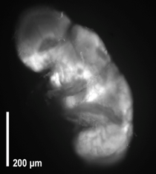

**B**



**C**

**1g**

**3g**



♀

♂

***Figure 1. Acute hypergravity exposure induces oxidative stress response genes and ROS fluorescence in w1118 flies. (A)*** *Volcano plot shows significant upregulation of oxidative stress genes in the brain tissue of male and female 2-3 day old W1118 flies subjected to 2hr of 3g. Red indicates upregulated genes and brown indicated downregulated genes. The dotted line is p-value < 0.05.* ***(B)*** *Representative image of fly brain subjected to hypergravity for 2 hrs and stained with DCFH-DA.* ***(C)*** *Histogram shows significant increase in the mean fluorescence intensity of DCFH-DA stained brains when imaged under UV light show significant increase in \* indicates p <0.05. Error bars represent standard error.*

Literature suggests that oxidative stress can lead to loss of dopaminergic (DA) neurons in Parkinson’s disease (24252804). Similarly, flies expressing GFP tagged tyrosine hydrolyase (Fig. 2A) when exposed to hypergravity (3g) from day 3 to day 18, show a significant loss of DA neurons (Fig. 2B).

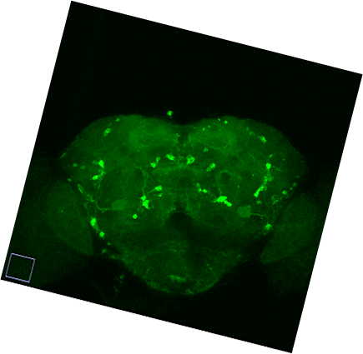

**A**

**B**

***Figure 2. Hypergravity leads to dopaminergic neuron atrophy.***

***(A)*** *Representative adult brain labeling DA neurons with GFP* ***(B)*** *Quantification of DA neurons in 18-day adult female flies exposed to hypergravity show decreased DA neurons as compared to 1g flies. \* indicates p< 0.05. Error bars represent standard error.*

*Linda:* ***Overexpression of Catalase in Mitochondria Mitigates the Inflammatory Effects of Simulated Microgravity and Social Isolation in Mouse Hippocampus***

There is well-based evidence that excessive reactive oxygen species (ROS) are one of the culprits leading to damage accumulation. We hypothesized that exposure to the space environment generates excessive ROS, which results in neuroinflammation and aging-like degenerative symptoms with relevant to the brain. We believe that the results of our research will have an important impact on developing specifically designed treatments for astronauts, which will enable longer and safer missions, while also contributing to basic aging research.

In our experiments we use the hindlimb unloading (HU) model mimicking microgravity with either paired or single housed animals (social isolation). We additionally use the transgenic mouse MCAT model, in which mitochondrial oxidative stress is quenched by the overexpression of human catalase.

We first focused on analyzing responses of the hippocampus to simulated weightlessness because of its key role in memory and learning. Mice were exposed either to HU (30d) or were kept as normally loaded (NL) controls. We extracted the hippocampus from the left hemisphere and analyzed ROS products and neuroinflammation. As a marker of oxidative damage, we measured the 4-Hydroxynonenal (4HNE) adduct, Park7(redox-sensitive chaperone and sensor for oxidative stress) by ELISA and conducted a cytokine array from the hippocampal brain homogenate (35 cytokines) as well as 8-hydroxy-2'-deoxyguanosine ELISA from serum.. In order to link the molecular and morphological brain changes to possible behavioral or circadian rhythm changes the mice were filmed 24 hours before sacrifice. By analyzing the behavior patterns from video collected during the experiment, our preliminary results showed that MCAT HU (socially housed) animals were more active and conducted more exploratory activities compared to NL. We have also detected a novel behavior related to use of enrichment in the social housed HU mice which we intend to explore further, since social isolation is also relevant to spaceflight.

Our recent results show changes in cytokines levels related to immune responses in the hippocampus are a consequence of simulated weightlessness and/or social isolation: Two-way ANOVA revealed significant interaction effecting HU and genotype in expression levels of IL-3, IL-10, Il-12, IL-17 and IL-1β in socially housed animals. (Figure 1) The elevation of these cytokines by HU in WT mice was mitigated in MCAT mice, suggesting a role for mitochondrial ROS signaling in the inflammatory brain response to microgravity. Interestingly, Il-3 and IL-10 displayed strong correlation to 4HNE adduct in hippocampus. Additional interesting patterns of cytokine expression were evident as a function of HU and genotype.

Figure 1:

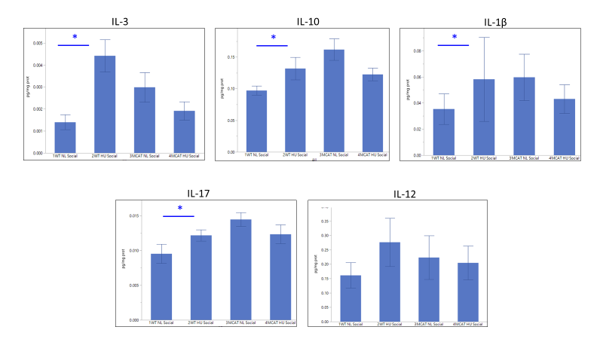

Figure1: Two-way ANOVA revealed interaction effects of genotype and treatment (loading) on five cytokines (out of 35) related to neuro-inflammation in social housed mice. Post-hoc (Dunnet’s) revealed that in four of these cytokines there was a loading effect, where HU had higher cytokine abundance, effect mitigated in mCAT, suggesting a role for mitochondrial ROS signaling in the inflammatory brain response to these stimuli.

We also found substantive cytokine responses to social isolation in the hippocampus; housing and genotype interaction effects were significant (by 2-Factor ANOVA) for fifteen cytokines from a screen of thirty-five. The affected cytokines were Eotaxin, G-CSF, IFN-gamma, IL-6, IL-9, IL-10, IL-13, IL-17, LIF, MCP1, MCSF, MIG, RANTES, EPO, Fractalkine and MDC. Many of these effects were mitigated in MCAT mice, pointing out a link between social isolation stress and ROS signaling. (Fig 1)

Figure 2:



Interestingly, we also observed a strong effect of social isolation on Park7 protein expression, where socially housed animals have higher abundance of Park7 than singly housed mice. Park7 functions as a redox-sensitive chaperone, as a sensor for oxidative stress and protects neurons against oxidative stress and cell death and its mutations are implicated in Parkinson’s disease. (Figure 3)

Figure 3:

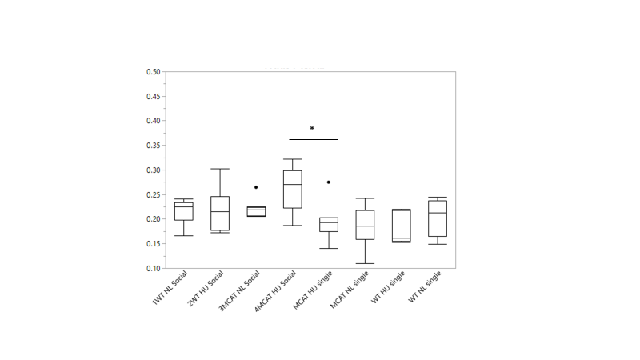

|  |  |
| --- | --- |
| ANOVA | P-Value |
| Housing (Social vs Single) | 0.0003 |
| Genotype (WT vs MCAT) | 0.241 |
| Treatment (NL vs HU) | 0.424 |

Figure3: There was a significant effect of social housing to increase Park7 protein expression in all groups compared to corresponding single housed controls, indicating a newly discovered compensation mechanism connected to ROS of Park7 to social isolation damage in the brain

Taken together, our results suggest that both microgravity and social isolation disrupt normal cytokine signaling and MCAT mice are at least partially protected from these changes. This implicates an important role for mitochondrial ROS signaling in hippocampus cytokine pathways. It is important to further illuminate the molecular basis underlying these changes to enable a safe long-term space travel in the future.

**Mouse Behavior and Cognitive Testing (Ronca Lab) – reduce length to most relevant**

***Behavioral phenotyping of mice in space***

The Ronca laboratory conducted a detailed behavioral phenotyping study of mice flown on the first NASA Rodent Research (RR1) in the Rodent Habitat (RH). Young adult (16-week-old) female mice were flown by NASA to validate the RH for long-duration (37-day) flight. Older (32-week-old female mice were flown by CASIS for 22-days. Treatments were: Flight (FLT) and Identically-housed ground control (GC) for video acquisition, and Vivarium (V) and Basal (B) ground controls for tissue collection (Choi & Ronca, 2015). RR1 video comprises a rich repository of clear images enabling highly detailed mouse behavioral phenotyping on orbit throughout the 30-day mission. Quantification of species-typical behaviors of the 16-week-old NASA mice on Earth and in Space revealed similarities and differences. Daily measures averaged across mission halves revealed comparable amounts of feeding, self-grooming, exploratory behavior, and amicable social interactions, e.g., huddling, allo-grooming. Antagonistic social interactions were observed in ground control but not flight mice. Rearing, which is operationally defined as lifting

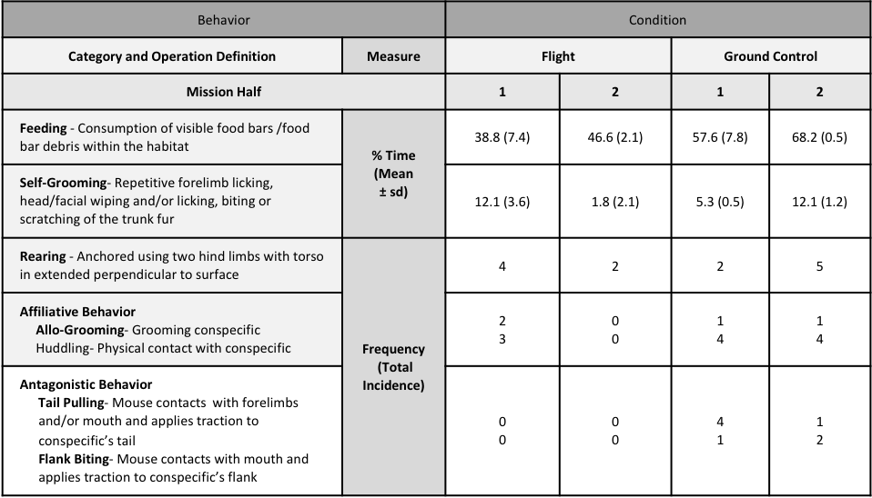the forebody against the gravity vector from a quadrupedal stance, was observed only in GC mice however FLT mice exhibit a similar behavior extending their forebodies away from the cage sides while tethered to the wall with their hindlimbs or tail. Social interactions including affiliative behaviors (huddling and allo-grooming), and antagonistic behaviors (tail-pulling and biting) were observed infrequently in both FLT and GC conditions thus group comparisons did not achieve significance.

The figures below depict behavioral findings analyzed across 8-day mission quarters (upper panel), and across 24 hourly samples on L+29 (lower panel). Numbers of mice in view are shown on the left. During Q1, (L+4 through L+11), ~50% of NASA FLT and GC mice were observed in the larger Filter (as compared to Lixit) area of the habitat during the dark cycle phase. Beginning during Q2, (L+12 through L+19), and persisting throughout the remaining mission quarters, FLT mice spent more time in the Filter area relative to the Lixit area as compared to GC mice. Ambulation is shown in the center. FLT and GC mice initially spent similar amounts of time ambulating (Q1). In Q2 and Q3, FLT mice exhibited significantly greater ambulatory behavior as compared to GC mice, and in Q4, a trend (p<0.10) toward greater ambulatory behavior was observed. Movement type is shown on the right. Quadrupedal ambulation (active use of all four limbs), forelimb ambulation (active use of both forelimbs), or free-floating (movement with no limb involvement) were compared. Significantly more quadrupedal ambulation than forelimb ambulation was observed in FLT mice. Forelimb ambulation was observed in FLT mice less than 25% of the time during the first half of the mission but was not observed thereafter Free-floating was quantified at low levels (<3% observed time) in FLT mice and absent in GC. The late-mission 24hr analysis provides clear evidence that the circadian timing system was intact during the last mission quarter. For spaceflight mice, total ambulation on L+29 was more than double that of ground control mice during the dark cycle.

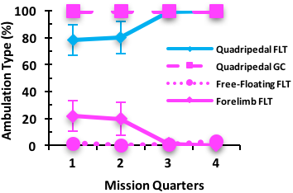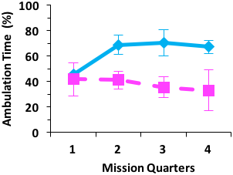

†

***p<0.01***

***p<0.01***

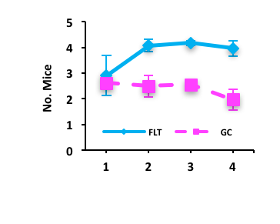

†

†

***p<0.01***

**Mission Quarters**

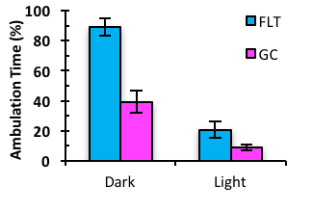

***p<.05***

***p<.05***

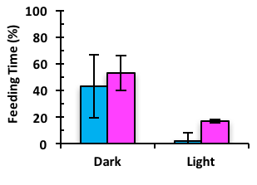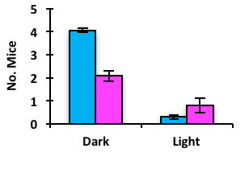

***p<.05***

***p<.05***

*NASA Flight (FLT) and Ground Control (GC) mouse presence and ambulatory behavior within the Filter area of the Rodent Habitat (RH) scored on each mission day averaged (mean ± SEM) across 8-day ISS mission quarters (Q1, L+ 4 to L+11; Q2, L+12 to L+19, Q3, L+20 to L+ 27; Q4, L+28 to L+35). Upper Left. Average (mean ± se) number of FLT and GC mice in Filter view during the dark cycle phase. Upper Center. Percent time spent ambulating by FLT and GC mice in the Filter area of the Rodent Habitat (RH) during the dark cycle phase across mission quarters. Upper Right. Percent time (across mission quarters) that FLT mice spent ambulating using either (1) all four limbs (Quadripedal Ambulation), (2) two forelimbs (Forelimb ambulation), or (3) no limbs (Free-Floating) compared to GC mice during the dark phase of the circadian cycle. Note: For FLT mice, the sum of quadripedal and forelimb ambulation, plus free-floating, accounts for 100% of the time that mice spent moving. †p<.10. Lower panel. Around-the-clock video surveillance of NASA FLT and GC mice hourly across light and dark cycle phases on L+29 normalized to total video duration and numbers of mice. Number of FLT and GC mice in view (left). Percent time (mean ± se) ambulating (middle) and feeding (right).*

To summarize, our data provide evidence for similar forms and levels of species-typical behavior, and the form of ambulation transitioning from an initial reliance on the forelimbs to quadripedal movement. NASA mice were significantly more active than identically housed ground control mice, and that greater activity was predominantly a function of incessant circling behavior. These observations underscore the need to apply standardized protocols and measures in rodent studies conducted using different habitats and environmental conditions. Data collected using the JAXA habitat, where male mice are singly-housed in relatively small compartments, comprises an important contrast for our existing study; translation comments.

Data from social and single housed HLU wt and mCAT mice- Report here

Emotionality Testing in Asphyxiated Adult Rats

The figure below shows the experimental design and apparatus used for novelty paradigm. In this study of asphyxia, rats were singly housed for 24hr then placed in an open field measuring (45w, 32h, 30d cm) and simultaneously videographed from the side and from below.

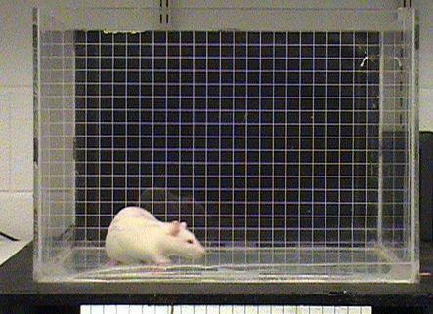

**Lights On**

**10 min**

**Lights Off Object**

**10 min 5 min**

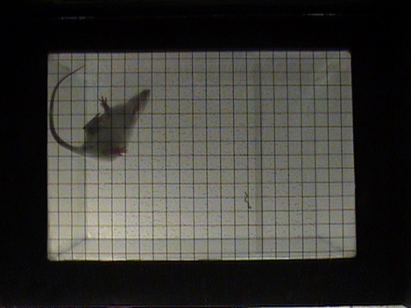

**= 1 min (Baseline or Response Measurement Interval)**

Side view: Locomotion (grid-crossings) analyzed. Telemetric data-loggers proposed in the current project will automatically tally activity levels.

View from Below: Thigmotaxis (the tendency to spend time near the wall rather than the center of test apparatus)

**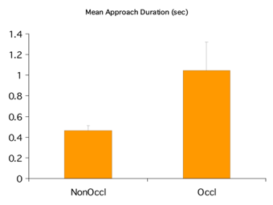**

**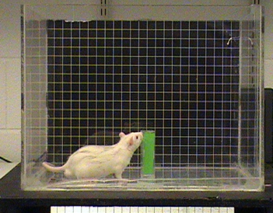**

Approaches to a novel object were slower (as measured by significantly reduced mean approach duration) in asphyxiated adult rats, suggesting a magnified response to novelty.

ENRICHMENT MOUSE TESTING INSTEAD HERE?

**Experimental Design:** This proposal aims to determine if oxidative stress and damage induced by radiation and/or microgravity exposure alters behavior, cognition, circadian rhythm and neuroimmune homeostasis that can be mitigated by overexpression of the antioxidant, catalase and/or a nicotinamide mononucleotide (NMN) enriched diet. Our specific aims will involve collection of blood and whole brain tissues from female and male, age-appropriate (per Appendix A) and age-matched *Wt*, *mCAT* transgenic mice, and mice fed on NMN enriched diet that were single- or social-housed to determine neuronal health and inflammation within the nervous and immune systems following exposure to single and combined irradiation and microgravity at multiple time points pre-, post-, and during exposure. Therefore, our parameters of assessment will include stress-induced isolation of single housed mice compared to social-housed mice, and sex-specific effects as well. In addition, these mice will be exposed to a battery of behavioral tests assessing memory, cognition, decision-making, and circadian rhythm fluctuation. For this, mice will be hindlimb unloaded for different amounts of time, with collections/behavioral assays performed at multiple timepoints (pre-exposure (baseline); days 2-, 7-, 14- and 30-exposure; and 14-days post-exposure (readaptation)). These mice would be simultaneously exposed to low dose radiation at the NASA Space Radiation Laboratory (NSRL) using the Simplified Five Ion GCR Simulation. Drs. Bhattacharya and Globus have extensive experience conducting experiments at NSRL.

From NRA: **The overarching question to be addressed in this research topic is: how do independent spaceflight environmental stressors/hazards in combination, interactive, or potentially ynergistically interact to modify operationally-relevant behavior and performance?**

The overarching question is comprised of (but not limited to) the following component research questions:

1. How can NASA ensure crew health and safety by identifying and establishing risks to crew health and performance related to interacting spaceflight environmental risks?

2. How can animal translational models contribute as appropriate and standardized analogs for characterization of operationally-relevant brain performance pathways?

3. Which stressors have the potential to produce the greatest risk?

4. What are the patterns and forms of stressor interactions? Are they additive and linear or do they exhibit non-linear behavior?

5. How do outcomes depend on the magnitudes, duration, and temporal order of stressor exposure(s)?

6. How do responses to combined stress depend on age of exposure and sex?

7. What brain performance pathways are affected by combined stressor exposure and do their responses share underlying mechanisms and adverse outcome pathways?

8. What is the magnitude of individual sensitivity to different stressors and are they correlated?

9. How can outcome measures be used to construct heuristic computational models that provide a means of analyzing and predicting overall risks?

It is critical that:

• \_Approaches ensure they provide a scientifically plausible conceptualization for how their animal model translates to acceptable operationally-relevant human performance requirements that could be met and sustained;

• \_Operationally-relevant brain performance pathways are assessed to prioritize identification and characterization of biological responses impacted by stressors and determine the nature of the mechanisms and combination principles that underlie the risks (accelerated, additive, synergistic, etc.).

To be responsive to this solicitation topic, investigators **must** provide evidence of an experimental conceptualization and methodological strategy that coherently addresses key components of the three CBS risks and an assessment of the extent to which their research is likely to contribute to NASA’s objectives of: 1) Identifying CNS effects and pathways impacted by space radiation dose and multistressor exposure temporal order effects that are likely to result in cognitive performance and sensorimotor changes; 2) Identifying adverse outcome pathways and improving risk estimation for performance outcome levels based on exposure magnitude and sequence effects of stressors (e.g., altered gravity exposure then irradiated vs. irradiated and then stressed, etc.); and 3) Providing scientifically plausible biophysical computational models focused on responses of operationally-relevant brain nodes/functional networks impacted by the three stressors. Additionally, **investigators must specifically address how their research results can be extrapolated to estimate risks to humans exposed to the space radiation environment while concurrently experiencing the stress of isolation and confinement and physiological adaptations due to altered gravity**. In this context, well vetted translational animal models that can represent human responses with high predictability/fidelity are of particular interest (Koppelmans et al. 2017; Mao et al. 2016; Pulga et al. 2016). **It is expected that research will be conducted according to the highest standards of scientific inquiry, addressing clearly stated, falsifiable hypotheses, and using the most advanced, validated methods available.**

**The overarching question to be addressed in this research topic is: how do independent spaceflight environmental stressors/hazards in combination, interactive, or potentially** **synergistically interact to modify operationally-relevant behavior and performance?**

**References and Citations**

1. Hodes, G.E., et al., *Individual differences in the peripheral immune system promote resilience versus susceptibility to social stress.* Proc Natl Acad Sci U S A, 2014. **111**(45): p. 16136-41.

2. Wang, X. and E.K. Michaelis, *Selective neuronal vulnerability to oxidative stress in the brain.* Front Aging Neurosci, 2010. **2**: p. 12.

3. Dias, V., E. Junn, and M.M. Mouradian, *The role of oxidative stress in Parkinson's disease.* J Parkinsons Dis, 2013. **3**(4): p. 461-91.

4. Paul, A.M., et al., *Osteopontin facilitates West Nile virus neuroinvasion via neutrophil "Trojan horse" transport.* Sci Rep, 2017. **7**(1): p. 4722.

5. Crucian, B., et al., *Alterations in adaptive immunity persist during long-duration spaceflight.* NPJ Microgravity, 2015. **1**: p. 15013.

6. Rummel, C., *Inflammatory transcription factors as activation markers and functional readouts in immune-to-brain communication.* Brain Behav Immun, 2016. **54**: p. 1-14.

7. Kanegawa, N., et al., *In vivo evidence of a functional association between immune cells in blood and brain in healthy human subjects.* Brain Behav Immun, 2016. **54**: p. 149-157.

8. Massudi, H., et al., *NAD+ metabolism and oxidative stress: the golden nucleotide on a crown of thorns.* Redox Rep, 2012. **17**(1): p. 28-46.

9. Solaini, G., G. Sgarbi, and A. Baracca, *Oxidative phosphorylation in cancer cells.* Biochim Biophys Acta, 2011. **1807**(6): p. 534-42.

10. Kristian, T., et al., *Mitochondrial dysfunction and nicotinamide dinucleotide catabolism as mechanisms of cell death and promising targets for neuroprotection.* J Neurosci Res, 2011. **89**(12): p. 1946-55.

11. Mills, K.F., et al., *Long-Term Administration of Nicotinamide Mononucleotide Mitigates Age-Associated Physiological Decline in Mice.* Cell Metab, 2016. **24**(6): p. 795-806.

12. Imai, S. and L. Guarente, *NAD+ and sirtuins in aging and disease.* Trends Cell Biol, 2014. **24**(8): p. 464-71.

13. Won, S.J., et al., *Prevention of traumatic brain injury-induced neuron death by intranasal delivery of nicotinamide adenine dinucleotide.* J Neurotrauma, 2012. **29**(7): p. 1401-9.

14. Wu, M.F., et al., *NAD attenuates oxidative DNA damages induced by amyloid beta-peptide in primary rat cortical neurons.* Free Radic Res, 2014. **48**(7): p. 794-805.

15. Liu, L., et al., *Exogenous NAD(+) supplementation protects H9c2 cardiac myoblasts against hypoxia/reoxygenation injury via Sirt1-p53 pathway.* Fundam Clin Pharmacol, 2014. **28**(2): p. 180-9.

16. Long, A.N., et al., *Effect of nicotinamide mononucleotide on brain mitochondrial respiratory deficits in an Alzheimer's disease-relevant murine model.* BMC Neurol, 2015. **15**: p. 19.

17. Crucian, B.E., et al., *Immune system dysregulation following short- vs long-duration spaceflight.* Aviat Space Environ Med, 2008. **79**(9): p. 835-43.

18. Lee, S.H., et al., *Neurophysiology of space travel: energetic solar particles cause cell type-specific plasticity of neurotransmission.* Brain Struct Funct, 2017. **222**(5): p. 2345-2357.

19. Stein, T.P., *Space flight and oxidative stress.* Nutrition, 2002. **18**(10): p. 867-71.

20. Amor, S., et al., *Inflammation in neurodegenerative diseases.* Immunology, 2010. **129**(2): p. 154-69.

21. Chang, T.T., et al., *Spaceflight impairs antigen-specific tolerance induction in vivo and increases inflammatory cytokines.* FASEB J, 2015. **29**(10): p. 4122-32.

22. Muid, S., et al., *Interleukin-6 and intercellular cell adhesion molecule-1 expression remains elevated in revived live endothelial cells following spaceflight.* Malays J Pathol, 2013. **35**(2): p. 165-76.

23. Stranahan, A.M., et al., *Blood-brain barrier breakdown promotes macrophage infiltration and cognitive impairment in leptin receptor-deficient mice.* J Cereb Blood Flow Metab, 2016. **36**(12): p. 2108-2121.

24. Vernon, P.J., et al., *Rapid Detection of Neutrophil Oxidative Burst Capacity is Predictive of Whole Blood Cytokine Responses.* PLoS One, 2015. **10**(12): p. e0146105.

25. Rochfort, K.D., et al., *Downregulation of blood-brain barrier phenotype by proinflammatory cytokines involves NADPH oxidase-dependent ROS generation: consequences for interendothelial adherens and tight junctions.* PLoS One, 2014. **9**(7): p. e101815.

26. Qin, L., et al., *Systemic LPS causes chronic neuroinflammation and progressive neurodegeneration.* Glia, 2007. **55**(5): p. 453-62.

27. Early, J.O., et al., *Circadian clock protein BMAL1 regulates IL-1beta in macrophages via NRF2.* Proc Natl Acad Sci U S A, 2018.

28. Argaw, A.T., et al., *IL-1beta regulates blood-brain barrier permeability via reactivation of the hypoxia-angiogenesis program.* J Immunol, 2006. **177**(8): p. 5574-84.

29. Wilking, M., et al., *Circadian rhythm connections to oxidative stress: implications for human health.* Antioxid Redox Signal, 2013. **19**(2): p. 192-208.

30. Andersen, J.K., *Oxidative stress in neurodegeneration: cause or consequence?* Nat Med, 2004. **10 Suppl**: p. S18-25.

31. Lochhead, J.J., et al., *Oxidative stress increases blood-brain barrier permeability and induces alterations in occludin during hypoxia-reoxygenation.* J Cereb Blood Flow Metab, 2010. **30**(9): p. 1625-36.

32. Zhu, X., et al., *Oxidative stress signalling in Alzheimer's disease.* Brain Res, 2004. **1000**(1-2): p. 32-9.

33. Jenner, P., *Oxidative stress in Parkinson's disease.* Ann Neurol, 2003. **53 Suppl 3**: p. S26-36; discussion S36-8.

34. Barber, S.C. and P.J. Shaw, *Oxidative stress in ALS: key role in motor neuron injury and therapeutic target.* Free Radic Biol Med, 2010. **48**(5): p. 629-41.

35. Ohl, K., K. Tenbrock, and M. Kipp, *Oxidative stress in multiple sclerosis: Central and peripheral mode of action.* Exp Neurol, 2016. **277**: p. 58-67.

36. Boskovic, M., et al., *Oxidative stress in schizophrenia.* Curr Neuropharmacol, 2011. **9**(2): p. 301-12.